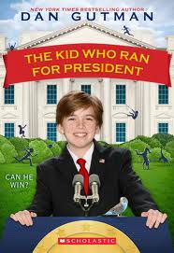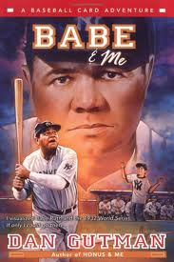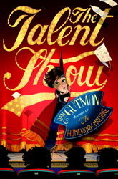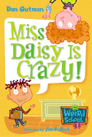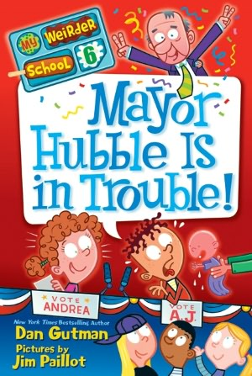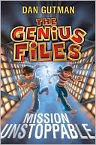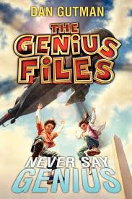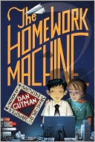

The High Bridge PTO and Board of Education are proud to announce that on May 23rd, your children will be meeting the enormously popular author, Dan Gutman. He has “devised a wonderful mechanism for teaching social history while telling a great tale”. He specializes in taking readers on journeys through history where they can learn about significant historical figures including several of their favorite sports heroes. Dan explains that he “doesn’t write about regular kids doing regular, believable kid things. I like surprise endings and cliff-hangers.”
Should you wish to have your purchase autographed for your child, please print your child’s name below.
_________________________________________________________________________________________________

Checks should be made payable to High Bridge PTO. Deadline for orders is April 25th. Any questions please email Coleen Conroy @ k.conroy2@comcast.net

Recommended for Kindergarten-Second:
Casey Back at $ 7.00________
In this picture book, with an entertaining rhyme that is styled after Ernest Thayer’s original poem, Dan Gutman offers Casey what any failed sports hero most desires – a second chance!

Babe Ruth and the Ice Cream Mess $ 4.00 _______
Part of the Ready-to Read series, the story of young Babe Ruth who finds a dollar and thinks his troubles will be solved.

This is a silly series for beginning chapter book readers. At Ella Mentry School, all the grownups are quite weird in their own weird way. The main characters are A.J. (a boy who doesn't like school) and his arch-enemy Andrea Young (who loves school and everything else A.J. hates).The adventures of A.J. and Andrea continue

My Weird School Series:
My Weird School Writing Tips $ 6.00________
Miss Daisy is Crazy! ( #1 $ 4.00________
Mr. Klutz is Nuts! (#2) $ 4.00________
Ms. Roopy is Loopy (#3) $ 4.00________
My Weird School Daze:
Mrs. Dole is Out of Control (#1 $ 4.00________
Mr. Sunny is Funny (#2) $ 4.00________

My Weirder School:
Miss Child Has Gone Wild! (#1 $ 4.00________
Mr. Harrison is Embarrassin! (#2) $ 4.00________
Dr. Nicholas is Ridiculous (#8) $ 4.00________

Recommended for Third Grade and Above:

The Genius Files #4 From Texas With Love (Hardcover) $17.00_________
After their explosive escape at Graceland, twins Coke and Pepsi are ready to resume their trip across America—only now in a convertible instead of the RV. They travel through Arkansas and Oklahoma, visiting weird-but-true tourist stops along the way, and finally end up in Texas, home of the Weird Capital of the Country, Austin. The twins' many enemies—the bowler dudes, Mrs. Higgins, and Dr. Warsaw—all swear that they're done chasing Coke and Pepsi for good. But when the twins start receiving more codes and ciphers from a mysterious robotic voice, they know someone's after them. They just have to figure out who before the mystery villain finds them first.

The Genius Files #3 You Only Die Twice (Hardcover) $17.00_________
The most dangerous road trip in history continues for thirteen-year-old twins Coke and Pepsi McDonald. Just when they thought they were safe, the twins will be chased by an evil Elvis impersonator, trapped in a pool of flesh-eating soda pop, nearly pulverized in a giant shredder, and crushed in a turbo-charged carnival ride. Worst of all, no one believes them! Will they make it out alive?

The Genius Files 2: Never Say Genius (Paperback) $ 7.00 _______
Today is Coke and Pepsi McDonald's thirteenth birthday. Someone's out to make sure they never make it to thirteen and a half. Follow the twins as they race across across America to defeat Archie Clone.

The Genius Files 1: Mission Unstoppable. (Paperback) $ 7.00________
In eight days, Coke and Pepsi McDonald are going to turn thirteen. Before then, they'll jump off a cliff, get trapped in the locked basement of their burning school, chased cross-country by murderous lunatics, left for dead in the pit of a sand dune, forced to decipher mysterious coded messages, thrown into a giant vat of SPAM, and visit the world's largest . . . ball of twine!

In these two novels, a twelve year old decides to run for President of the United States. While having a great laugh, students will learn about constitutional amendments, the Electoral College, how laws are passed and how we elect our President!

The Kid Who Ran For President $ 7.00_________
The Kid Who Became President $ 7.00_________

BASEBALL CARD ADVENTURES:
This series brings the legends of baseball back to life! Join Stosh as he travels through time and meets baseball legends like Honus Wagner in Honus & Me.
Ted & Me (hardcover) - $16.00__________
Roberto & Me $ 6.00_________
Honus & Me $ 6.00 _________
Babe & Me $ 6.00_________

The Talent Show (paperback) $6.00_________
A rock and roller. A ballerina. A comedian. A rapper. A singer. Which one will win the Cape Bluff Elementary School talent show? Or maybe it will be the kid you least expect.
The Homework Machine $ 6.00 _________
Four unlikely fifth grade students are brought together when they each discover the homework machine. Unfortunately things quickly get out of control, and they are in more of a mess than they ever thought possible.
The Return of the Homework Machine $ 6.00 ________
Snik, Brenton, Judy, and Kelsey haven't stayed in the best touch since last year's big homework-machine scandal. But they are all pulled back together again when Brenton realizes that the most powerful part of the machine -- the one that lets you cheat on homework -- was never really destroyed. And there is someone out there who wants to use it for a lot more than cheating.

Student Name: ___________________________________________ Total # Books __________
Check #_____________ Total $____________________

