Name: ________________________________________Phone Number: _________________________________

Student’s Name:__________________________________________ Grade/Teacher:_______________________

|  |  |  |  |  |
| --- | --- | --- | --- | --- |
| ***$13***  ***Color: Black***  ***Sizes: YS – AXXL*** | ***$10***  ***Color: Black***  ***Sizes: YS - AXXL*** | ***$21***  ***Color: Black***  ***Sizes: YS - AXXL*** | ***$15***  ***Color: Black or***  ***Heather Gray***  ***Sizes: YS – AXXL*** | ***$13***  ***Color: Black***  ***Sizes: YS-AXXL*** |
| ***$25*** | ***$25*** | **“TOPPERS” White Crew Sock (Small or Medium)**  ***$10*** | **Aluminum Water Bottle**  ***$11*** | ***$10*** |
|  |  | ***\*NEW ITEM\****  **Black Knit Beanie Cap with Ram Logo**  ***$11*** |  |  |

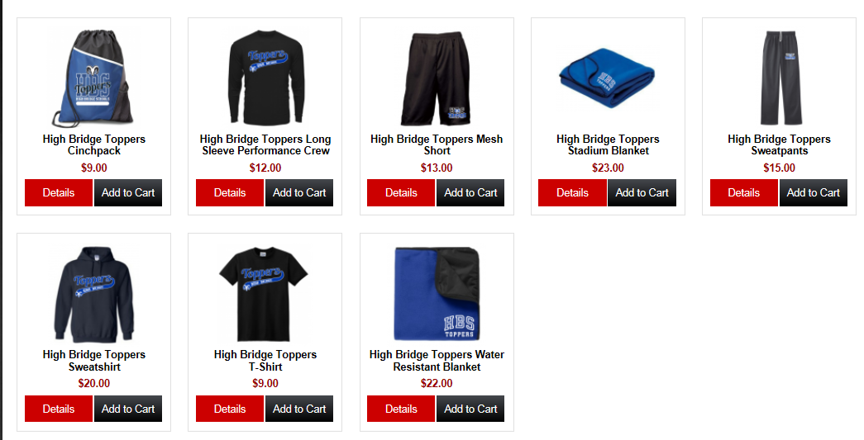

|  |  |  |  |  |
| --- | --- | --- | --- | --- |
| Item | Size | Quantity | Cost | Total |
|  |  |  |  | $ |
|  |  |  |  | $ |
|  |  |  |  | $ |
|  |  |  |  | $ |
|  |  |  |  | $ |
|  |  |  |  | $ |
|  |  |  |  | $ |
|  |  |  |  | $ |
|  |  |  |  | $ |
|  |  |  |  | $ |
|  |  |  |  | $ |
|  |  |  |  | $ |
|  |  |  |  | $ |
|  |  |  |  | $ |
|  |  |  |  | $ |
|  |  |  |  | $ |
| Additional Charge for XXL |  |  | $3.00 | $ |
|  |  |  | ***GRAND TOTAL*** | $ |

**PLEASE MAKE CHECKS PAYABLE TO: HIGH BRIDGE PTO**

**Please put the order form & payment in an envelope marked “PTO”**

**Any questions? Contact Jessica Banach:** [**hbptoesvp@yahoo.com**](mailto:hbptoesvp@yahoo.com) **or 732-501-5966**